|  |  |
| --- | --- |
| https://lh7-us.googleusercontent.com/Iql_8P3hjz1KiUwPAO3bLjpknxRRmZvbywvDeYUcxwVfy2tJM7R1GCfZ-BV93vaD9e8eawznObkvjcMEAXWdru2WgGHpcfI27crcR7k8FTgtvxIBrINIV_AxHL_Oi9xdDs1XwhHqJiJKnzZxbD134QE | ZewailCity for Science and Technology  Nanotechnology and Nanoelectronics  Engineering major  2023/2024 |

***Temperature Transducer***

|  |  |
| --- | --- |
| **Course** | Naneng203: Electric Circuits |
| **Assessment** | Project |
| **Due Date** | 21/5/2024 |

**Team members**

|  |  |
| --- | --- |
| **Name** | **ID** |
| Wafaa Sherif Gomaa | 202200191 |
| Ziad Haithem | 202201027 |
| Ali Ehab | 202200102 |
| Toqa Tarek | 202200885 |

Report

## Aim

This project aims to create a low pass filter by amplifying and filtering a noisy signal from k-thermocouple in order to measure the temperature ac curately solving the problem with small voltage signals, as this this the only signals that will pass so it will appear clear and the reader will be able to read the voltage clearly resulting in better temperature voltage.

## Block diagram/ panning



**Description of the System:**

**Amplifier:** the signal from the thermocouple is a low-voltage electrical signal we must amplify it to be able to get a good reading from the output device.

**Filter**: it will remove the noise (unwanted frequencies) of the signal as the thermocouple does not produce a pure signal of a single frequency.

**Process:**

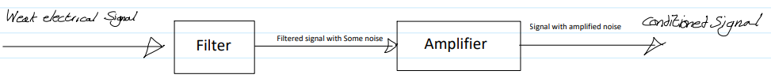

By filtering the signal first then amplify, it would produce a signal with a high signal to noise ratio (SNR). This is a consequence of there being no ideal filters as such the filtered signal would still have some noise which would be amplified.

By amplifying first we amplify both the component of our signal that we want and the noise but then when our signal passes through the filter this amplified noise is filtered. Again ideal filters don’t exist and such there is still noise however the SNR is lower than filtration then amplification.

## Acquiring the signal and displaying it

We measured the thermocouple signal using analogue discovery (AD) 2 connected to a laptop.

We connected the thermocouple to the AD 2 and heated the thermocouple using a heat gun.

Using the scope setting of the application waveforms we found that we received a very low voltage spikey signal with peaks of about 2.6 mV.

We exported this data from waveforms as a text file and displayed it using a grounded voltage source in LTSPICE.

## Signal Analysis

We now needed to know what component of our signal contained the temperature data.

We know that the component of the signal containing the temperature data would have the greatest magnitude and we should filter the other components of the signal.

The frequency of the component containing the temperature data is nearly impossible to tell just by looking at the noisy signal in the time domain.

As such we need to take our data from the time domain to the frequency domain as we should see a clear peak in magnitude at a particular range of frequencies with all other frequencies having very small magnitude.

To do this we used MATLAB and applied a Fast Fourier Transform (FFT) to our data which too our data from the time domain to the frequency domain.

Here are the steps we took to achieve this.

* Took our signal data from our text file and put it in an excel sheet since MATLAB imports data from excel files easily, the time and voltage data were imported as a 2xn matrix.

(where n is the number of data points)

* Applied an FFT to the voltage data from our signal using the fft() MATLAB function.
* Shifted the data so it would centered around the zero frequency using the fftshift() MATLAB function.
* Separated the real and imaginary components of the shifted FFT of our voltage data into nx1 column vectors to be plotted separately.
* Made a frequency vector using our time data for the plotting of the x-axis.
* Plotted the data.

(MATLAB Code has been submitted on google classroom)

### The real component

The real component of the signal represents the amplitude of each component of the signal as a function of its frequency.

We see that there is clear peek at the 0 frequency and as such we can conclude that the component of the signal containing the temperature data is the DC component of our signal

With all other frequencies containing noise and as such needing to be filtered out

## Circuit Design

### The first software design for the (without any hardware application):

Our circuit has 2 jobs.

* Filtering frequencies above the 0 frequency (Achieved via a low Pass filter)
* Amplifying the filtered signal to a point where its easily readable

#### *A diagram of a circuit Description automatically generatedFilter desig*n

We designed a 3rd Order RC low pass filter with capacitance and resistance values available in the electronics market.

The aim was to get a cutoff frequency as low as possible using reasonably available parts

The cut off frequency of each individual filter was calculated using the equation.

The 3rd Order Low pass filtered provided a cutoff frequency of

C = 100nf

R = 1.5 MΩ

n = 3

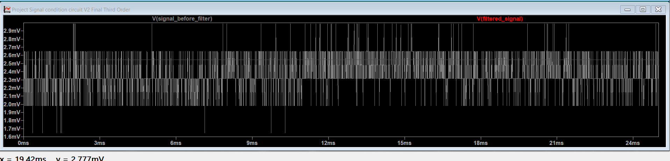

The red straight line is our filtered signal, and we see that we have successfully filtered out most of the noise and extracted a D.C Voltage signal about 2.56 mV.

#### Amplifier design

We used a universal amplifer to amplify the filtered signals voltage

The Green line is our amplified signal and the blue line is our near zero pre-amplified signal

### The second software design for the circuit (after hardware application):

While implementing the first design we faced some issues as we couldn’t see variation of voltage we tried some tests to eliminate the issues and we found that the 3rd order filter didn’t work so we replaced it by 2nd order one. Also we needed to change the values of resistors and capacitance, we increased them to 1Megaohm and 220μF to decrease the value of cutoff frequency to be able to observe the variation.

*Filter design*

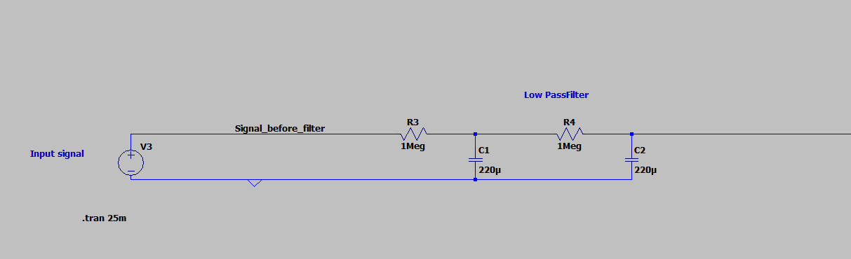

2nd order filter with new values

#### Amplifier design

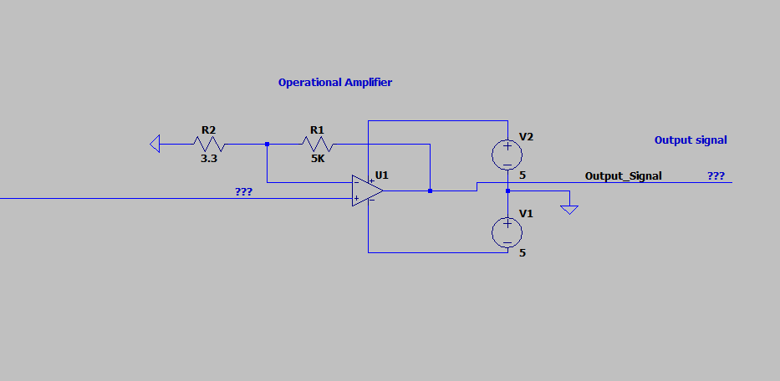

The amplifier with change in R2 to match the new cutoff frequency so that output would be reasonable.

### The final design for circuit:

#### Amplifier design

After trying again with the other design we didn’t reach the desired outcome, so we kept doing more tests and we found out that the values of capacitance and resistance are working and the 2nd order filter filters the required signal but the process had some issues, as the signal being filtered before amplified produces higher SNR, and it decreases the quality of the signal. So we reversed the process and started by amplifying the signal then filtering it with the 2nd order filter.

But we faced an external issue which we couldn’t fix as the thermocouple appeared to have some issues, sometimes it works and other times it value of voltage doesn’t vary, and when we brought another one from another group and it worked. So we checked everything and the signal using DC generator, we found that the circuit is functioning properly and the thermocouple is the issue. And that was the final circuit design.

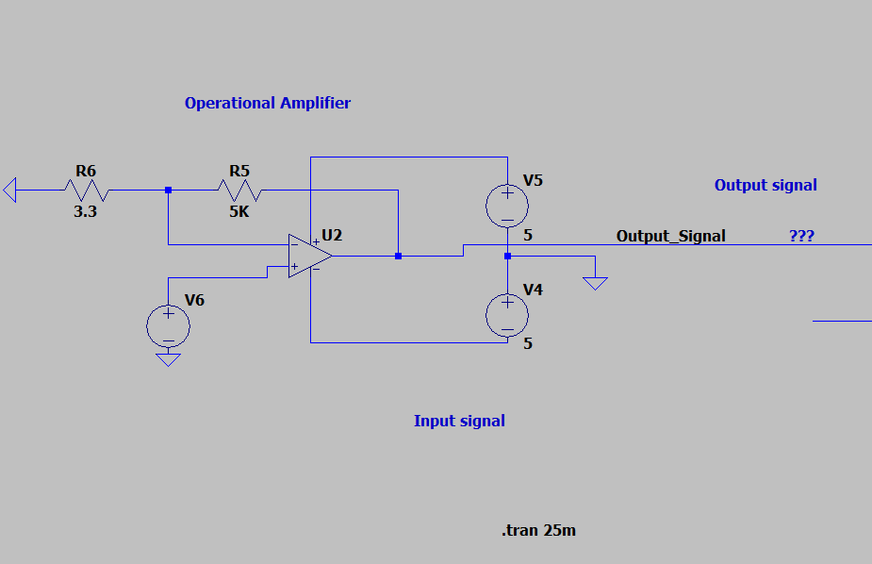

*Filter design*

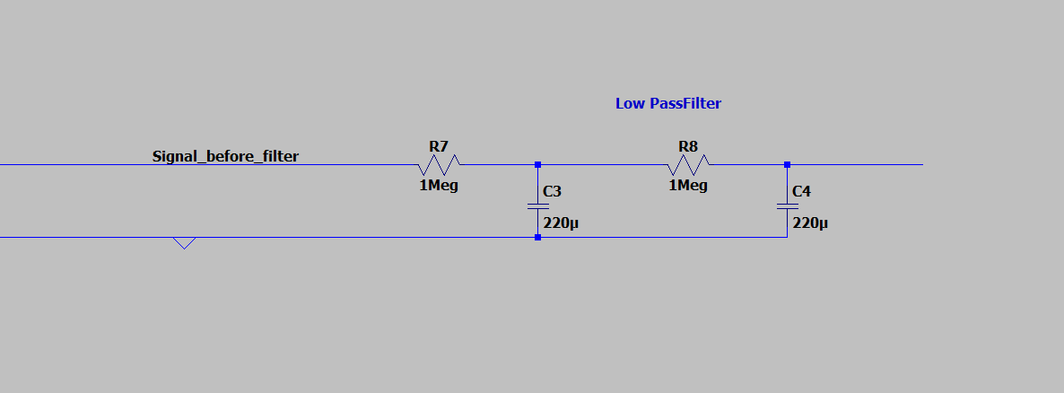

*Hardware design*

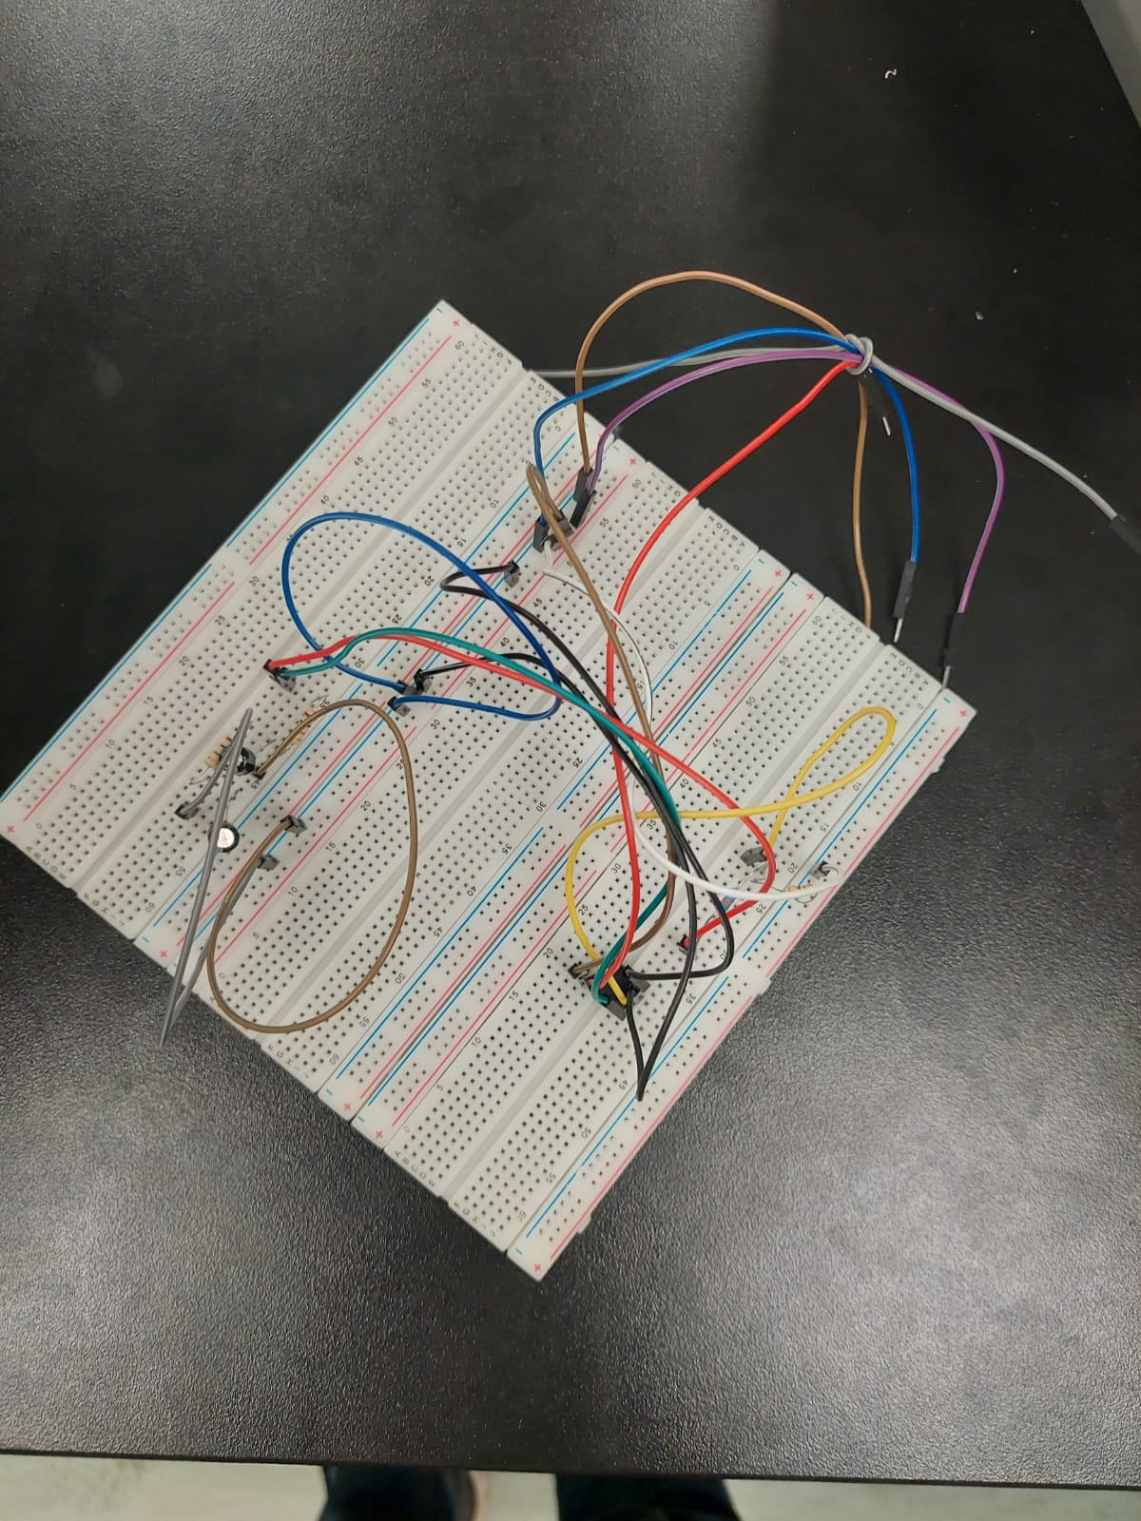

## Results

The results will show the spectrum for the signal.

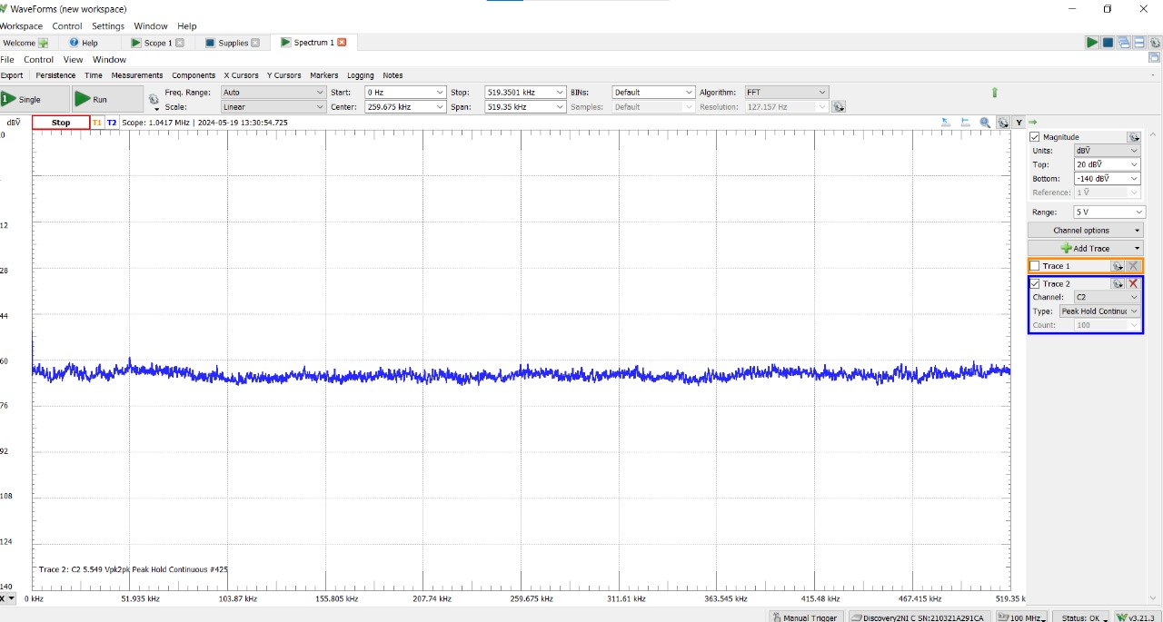

“Input signal”

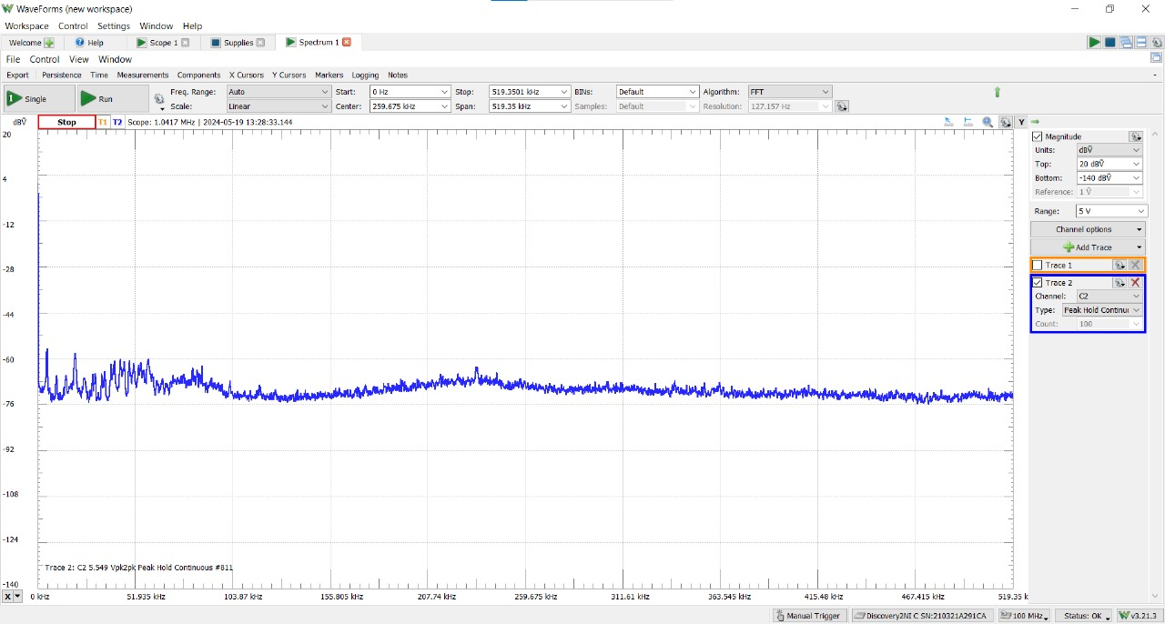

[“Amplified signal”

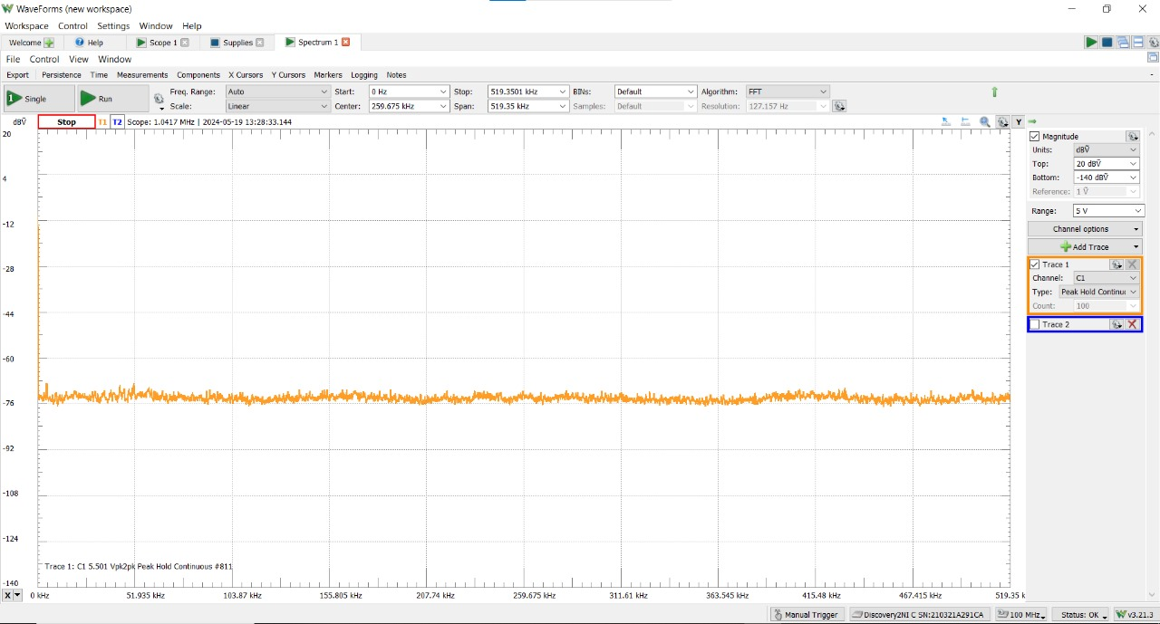

J[“output signal(after amplification and filtration)”

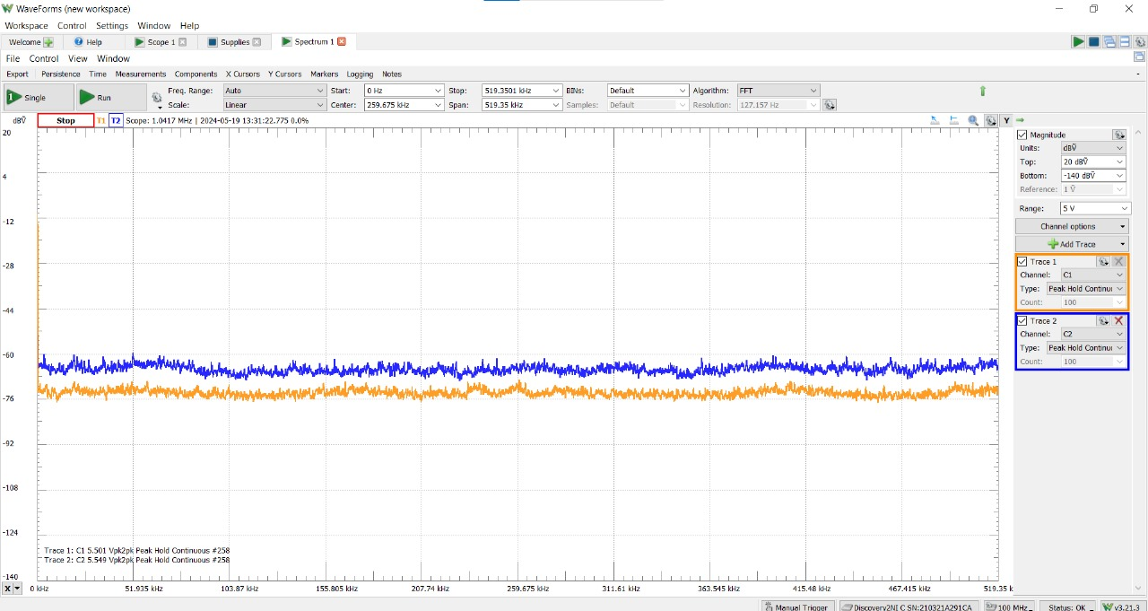

“Input signal vs. Output signal”

## Summary:

We received a noisy low voltage signal from a thermocouple using an AD 2, we then analyzed the signal using MATLAB to determine the frequencies at which the component of the signal containing the data about the temperature are. We identified the useful component of the signal to be the D.C component of our signal, We designed a lowpass filter to remove the noise from our signal and amplified the signal using a OP-AMP. Then We did 3 circuit designs reaching the required one which gave us the signal needed,